# Mockups

1. Projects List

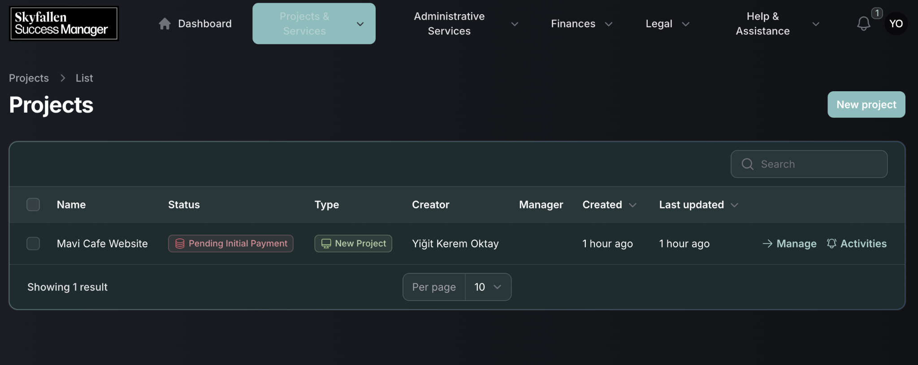

1. Project Request Wizard

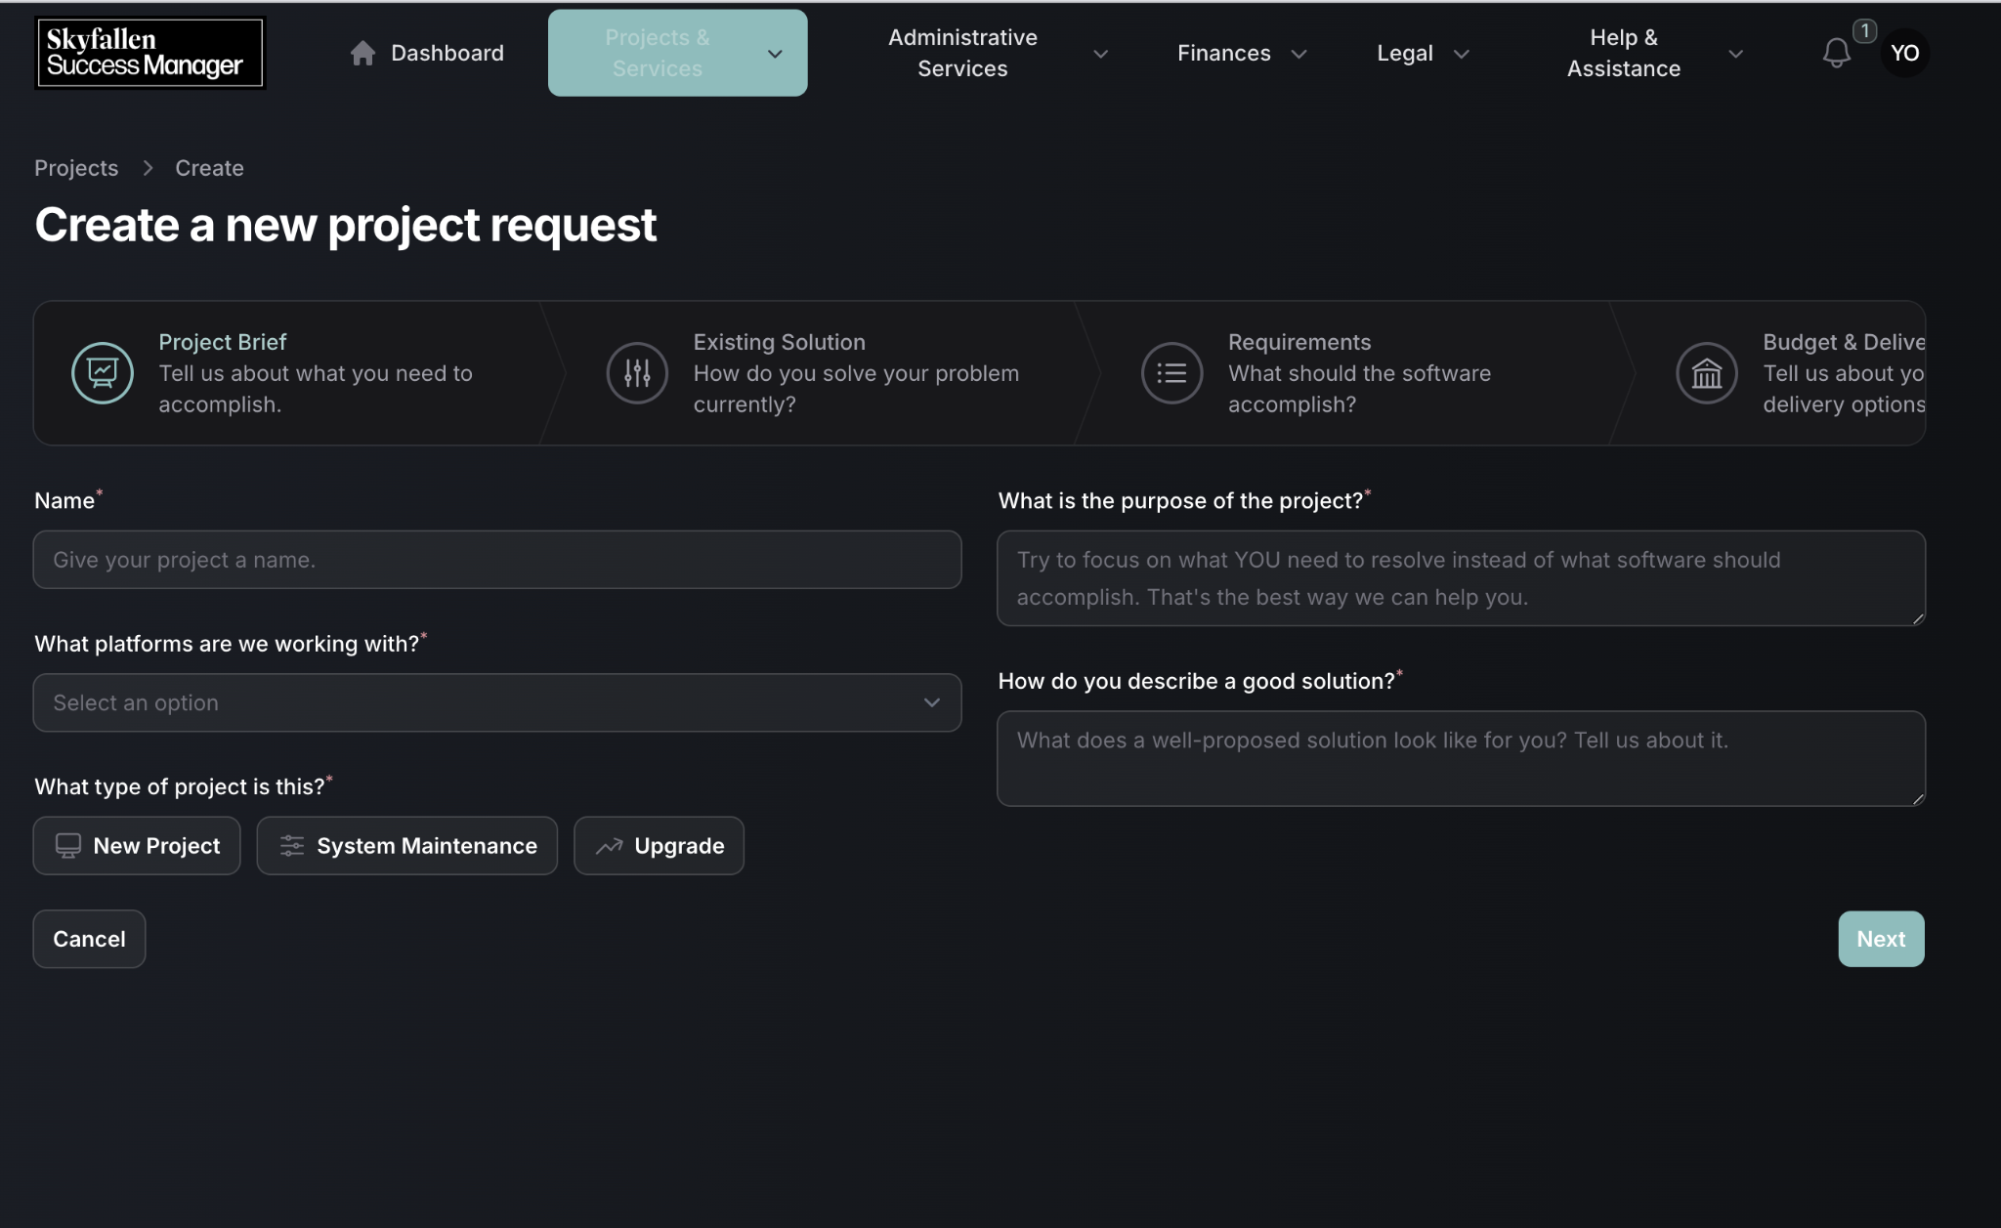

1. Project Requirement Wizard

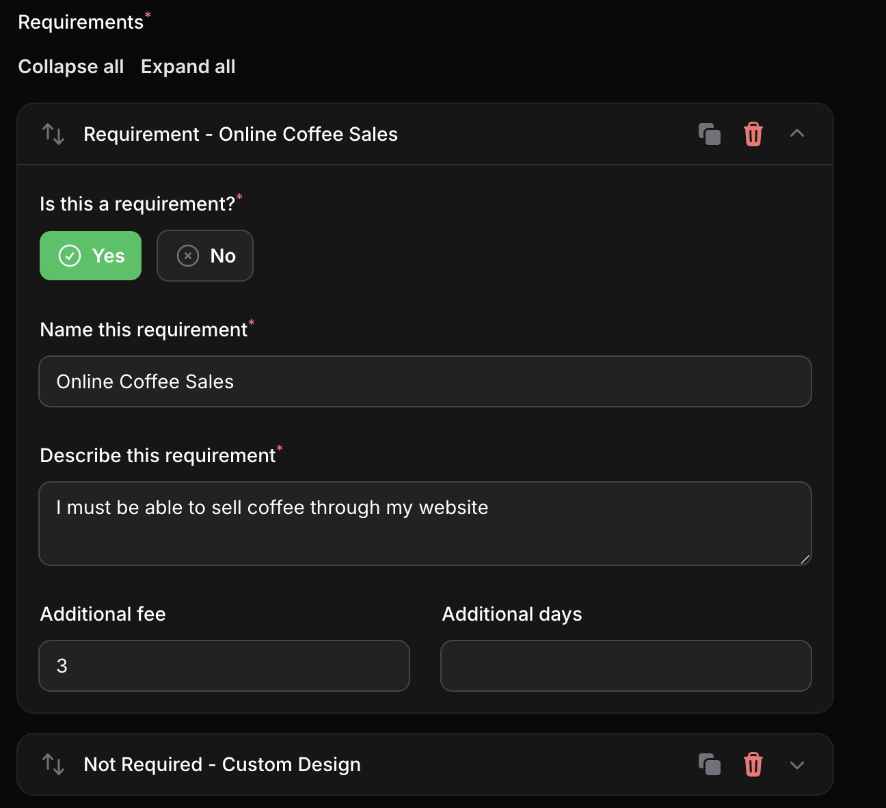

1. Edit Project Page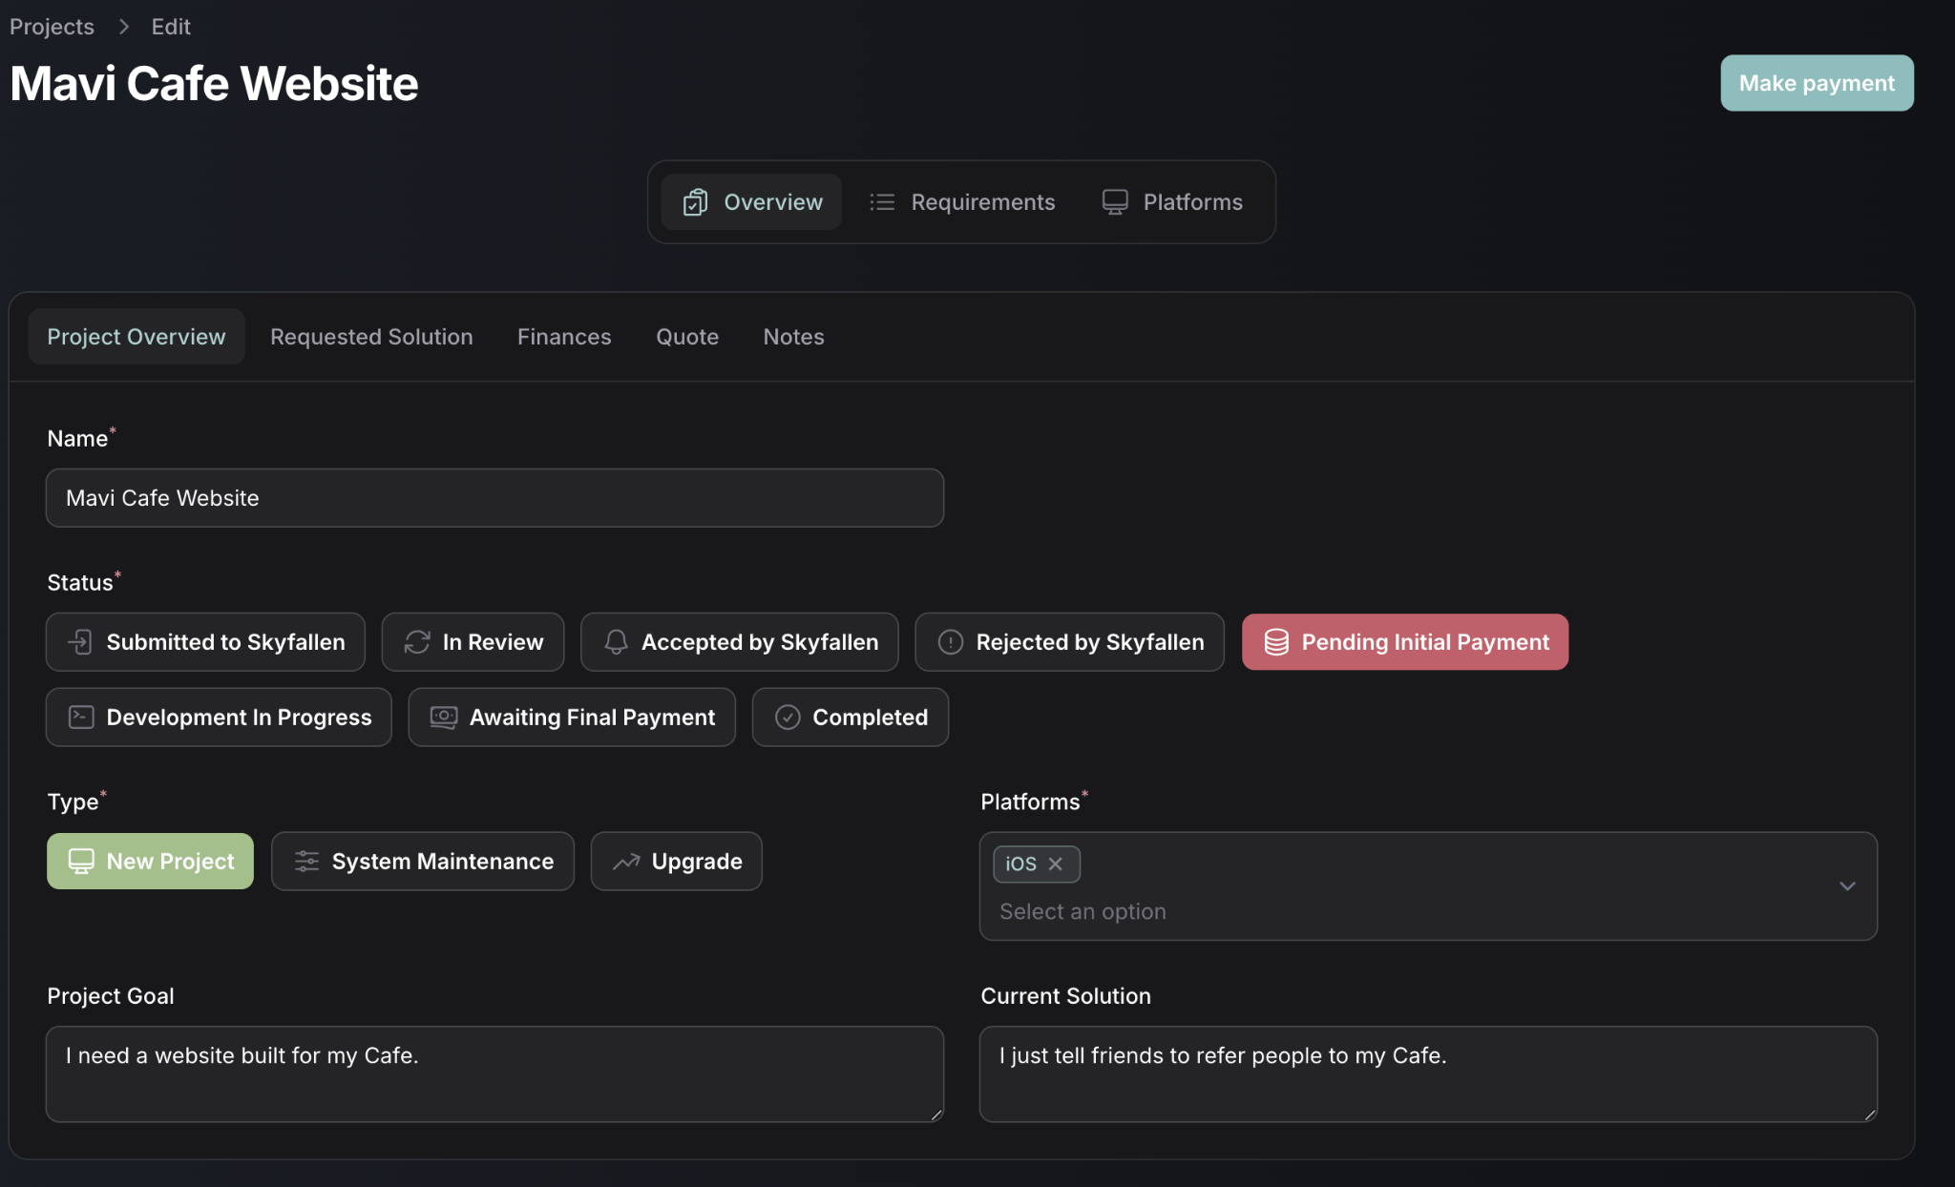
2. Create subscription template

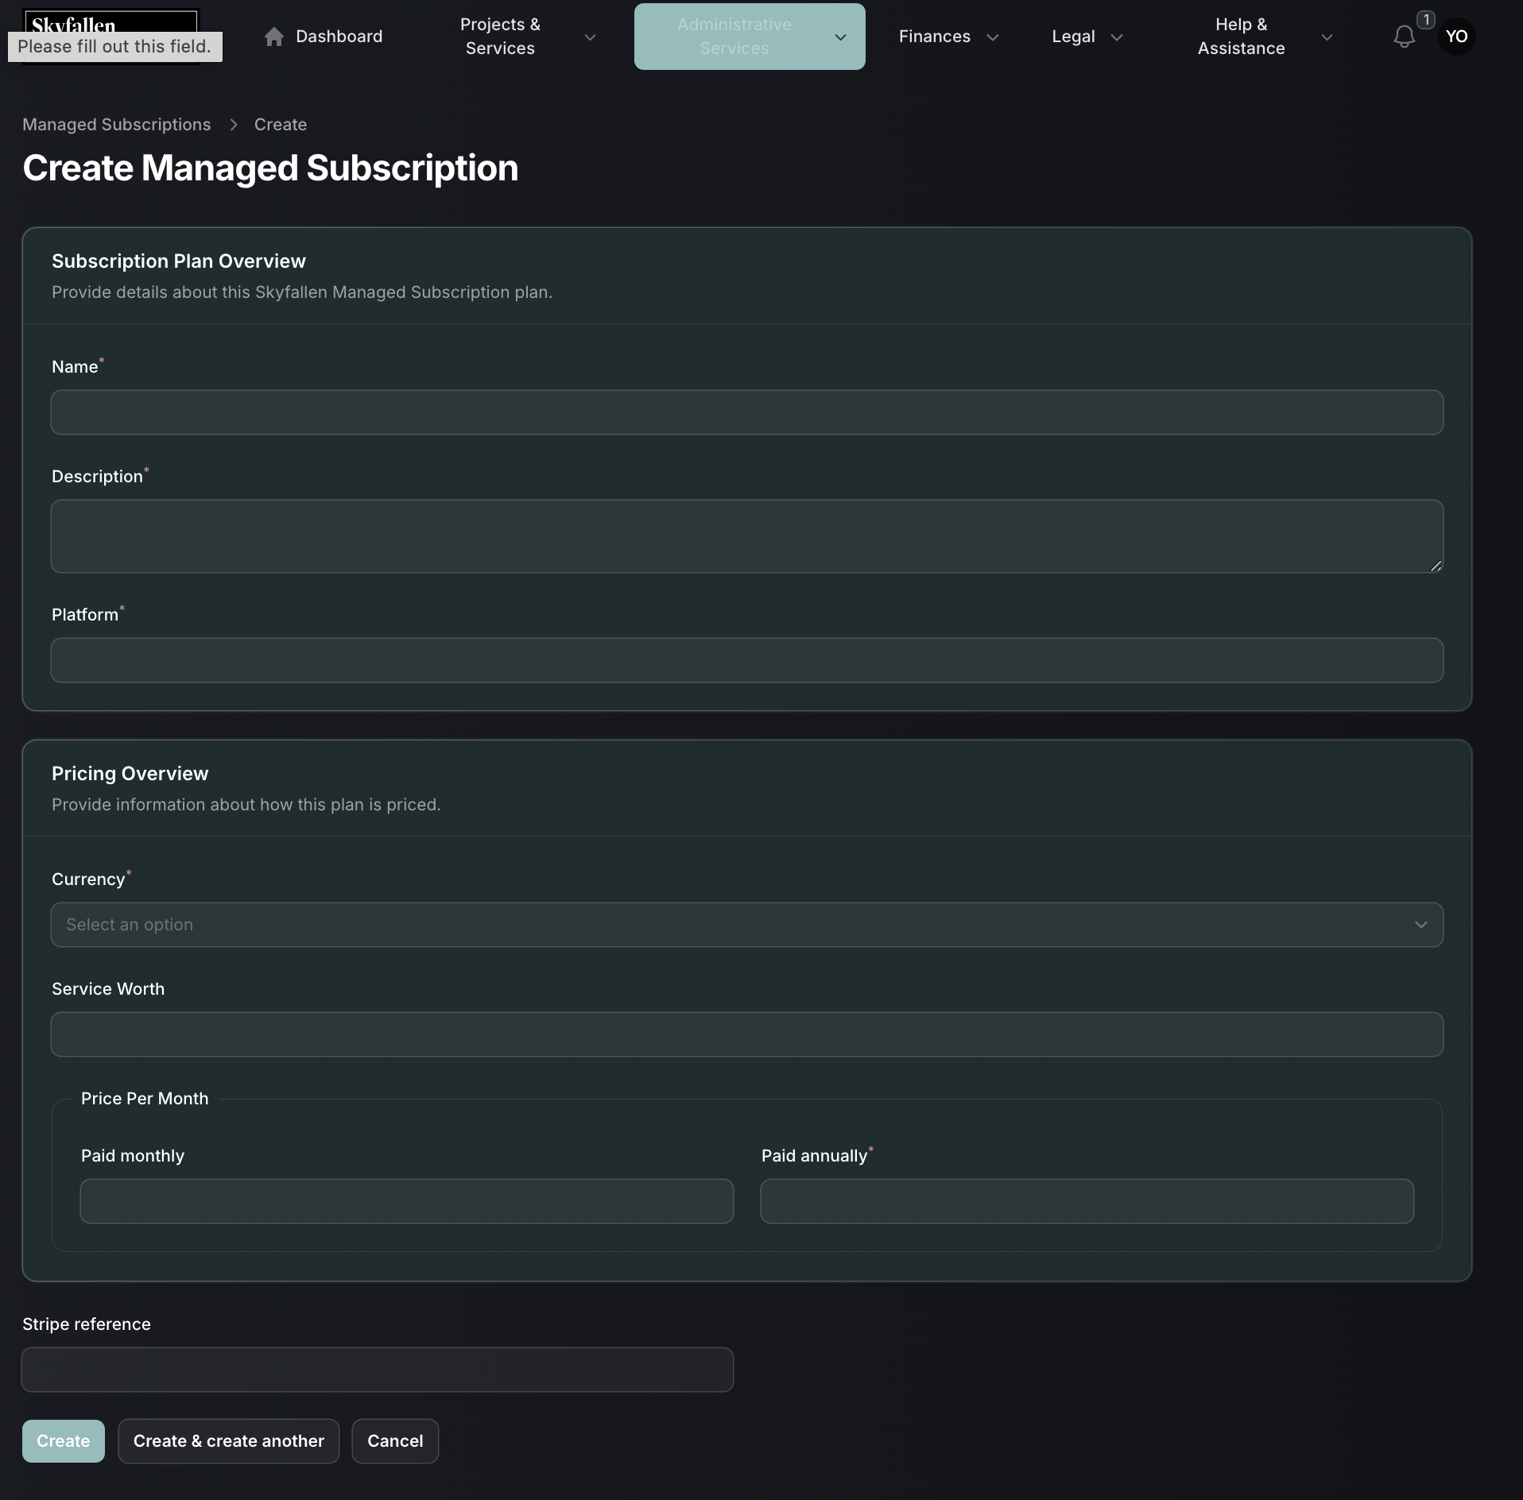

1. Edit subscription template

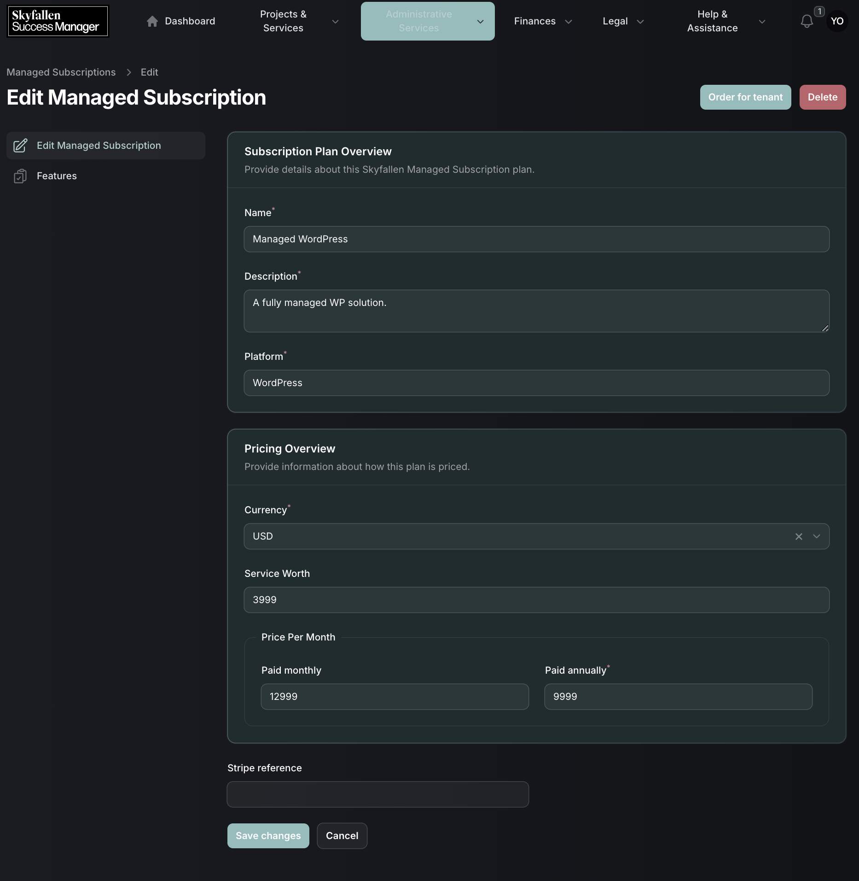

1. Subscription order modal

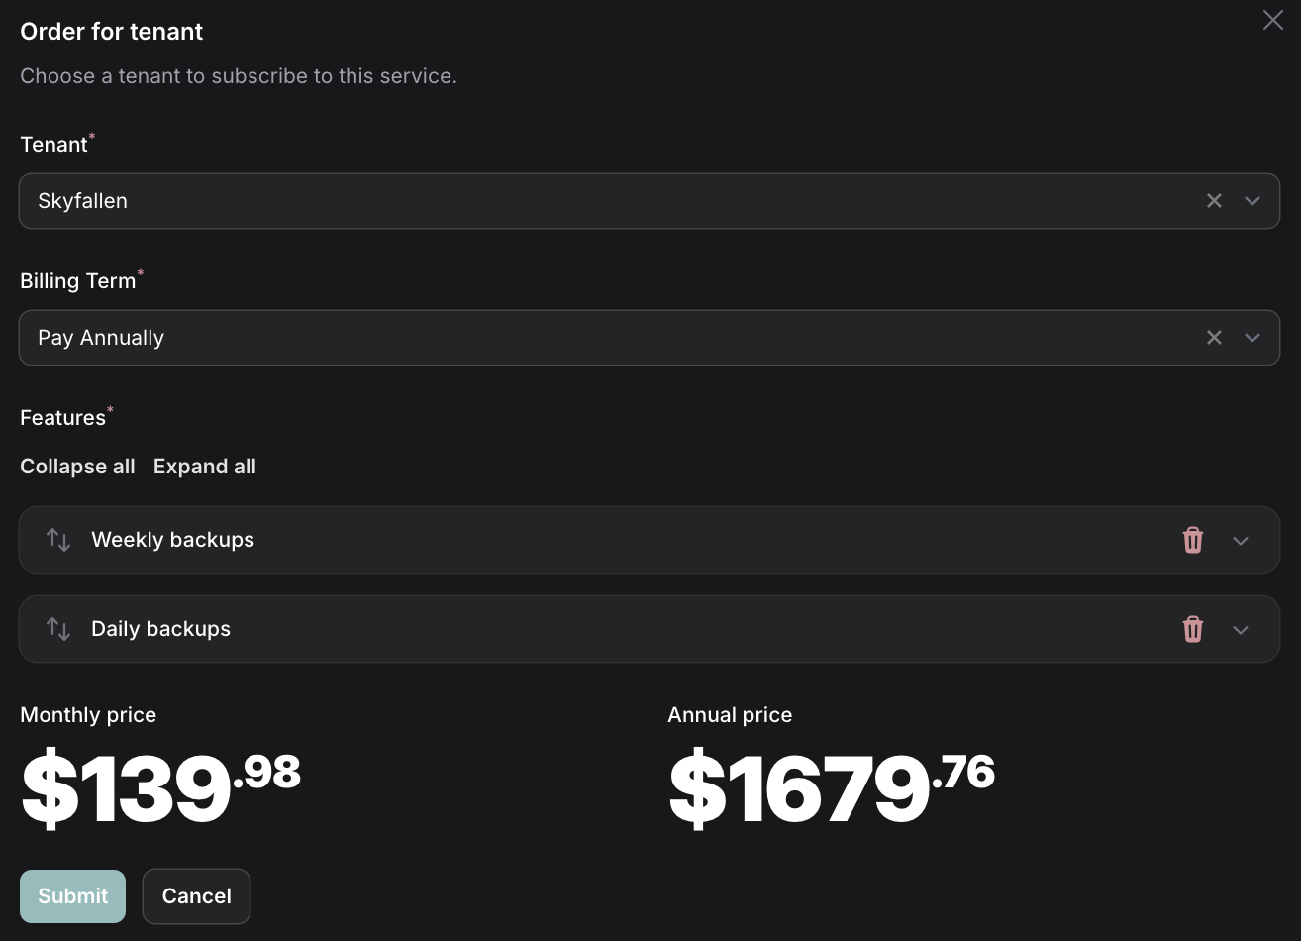

1. Subscription plan features

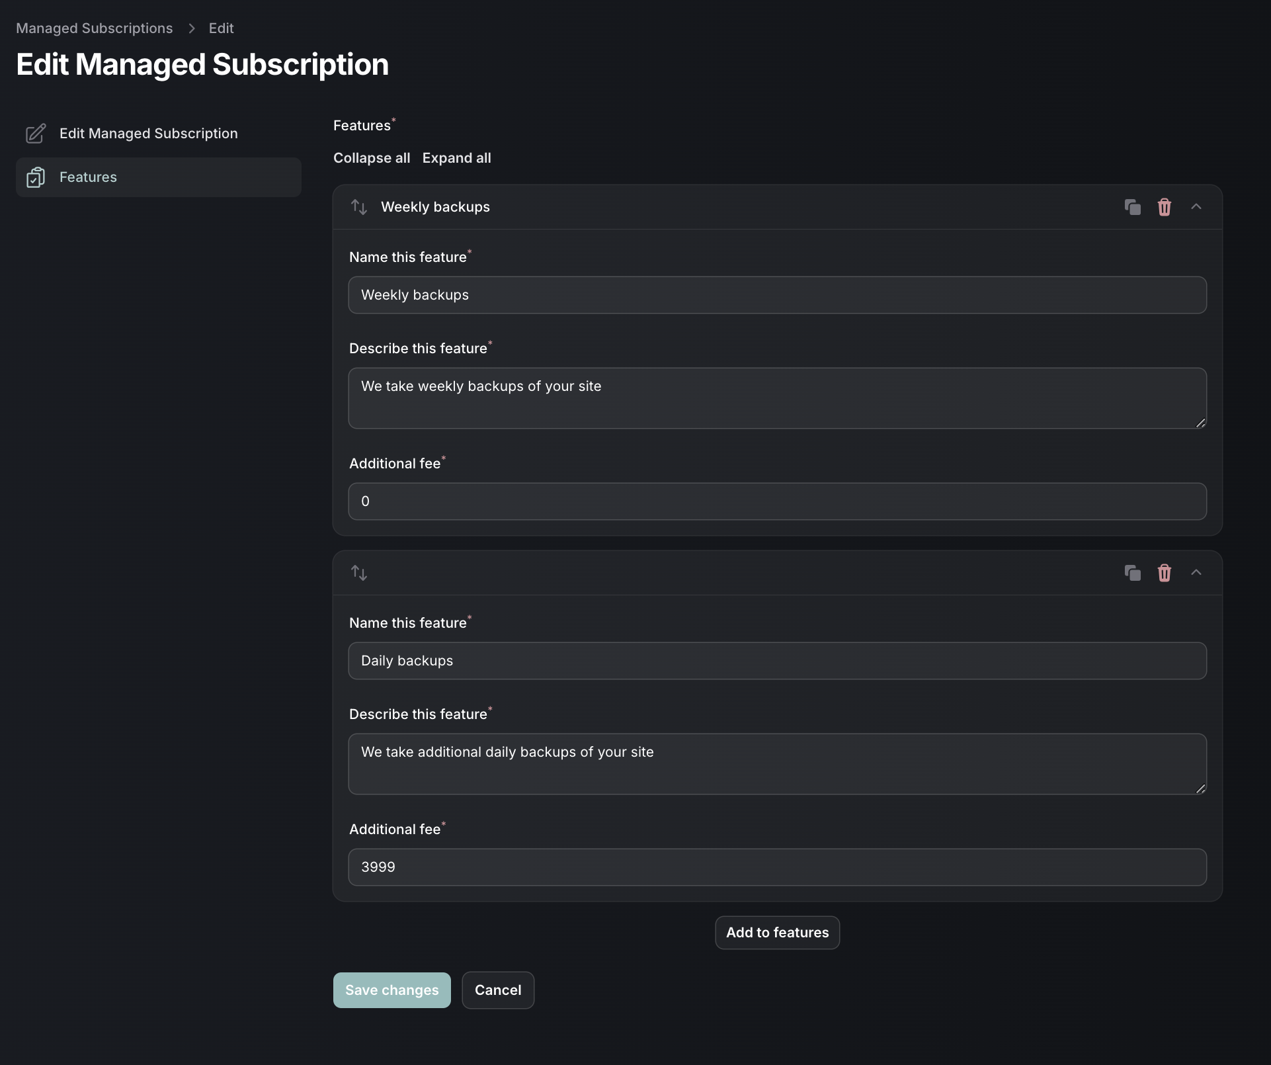

1. Customer subscriptions list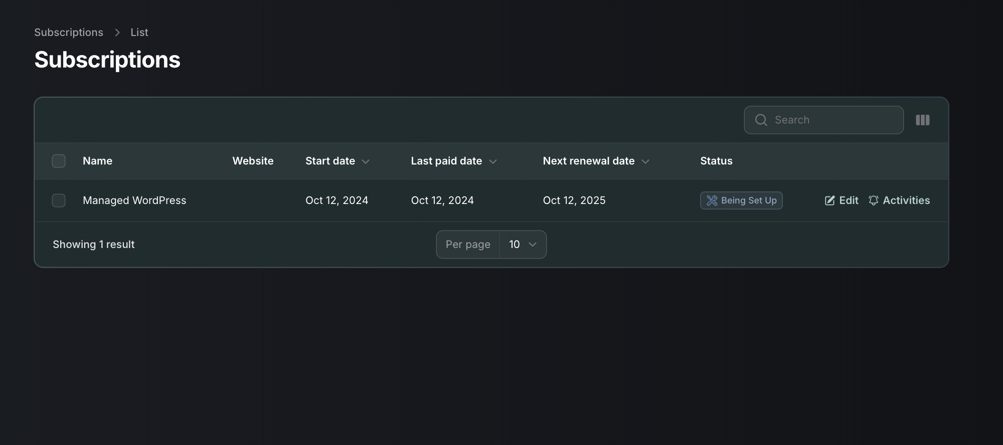
2. Customer subscription details

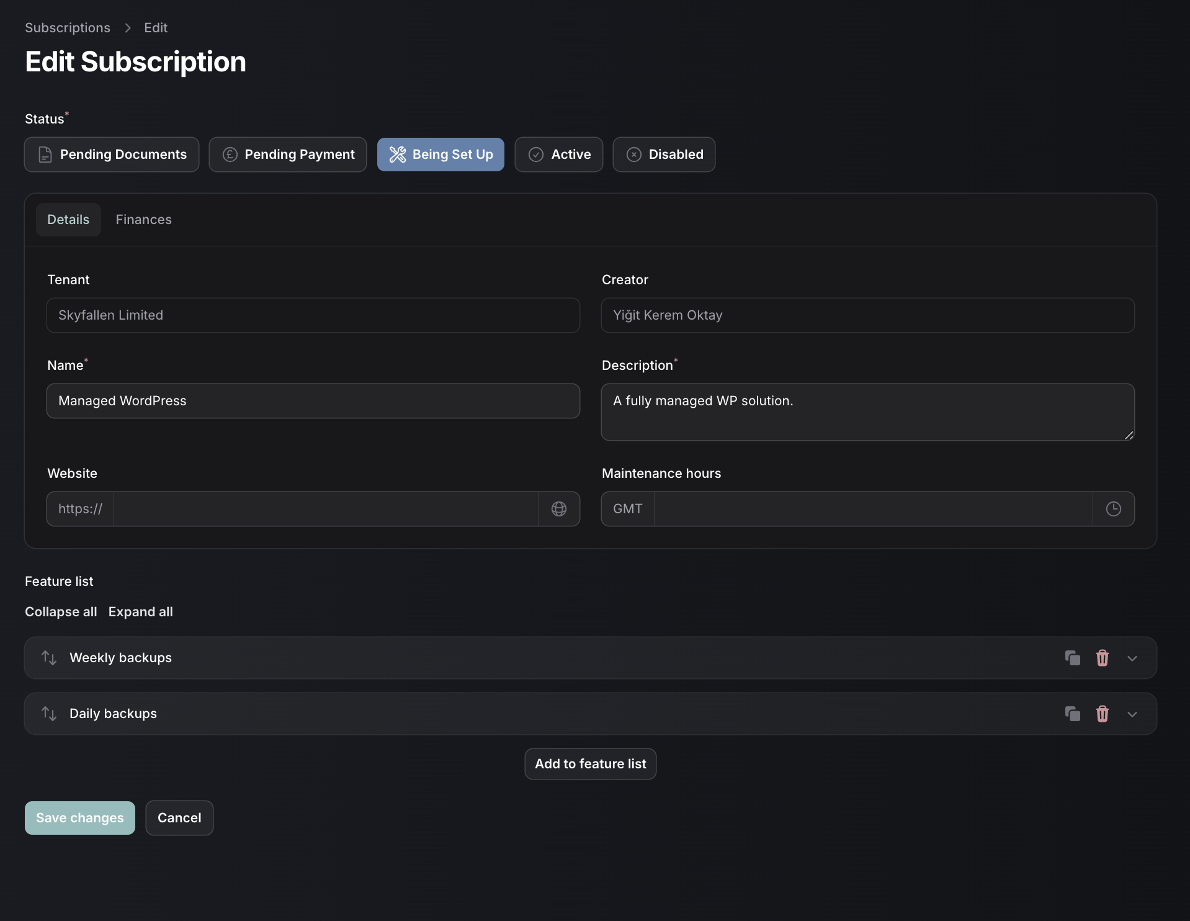

1. Customer subscription payment interface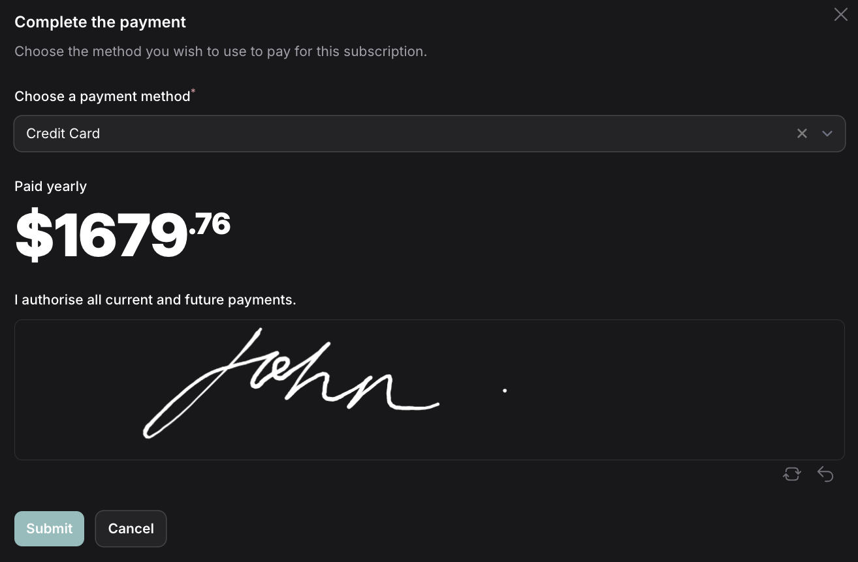
2. Invoice list

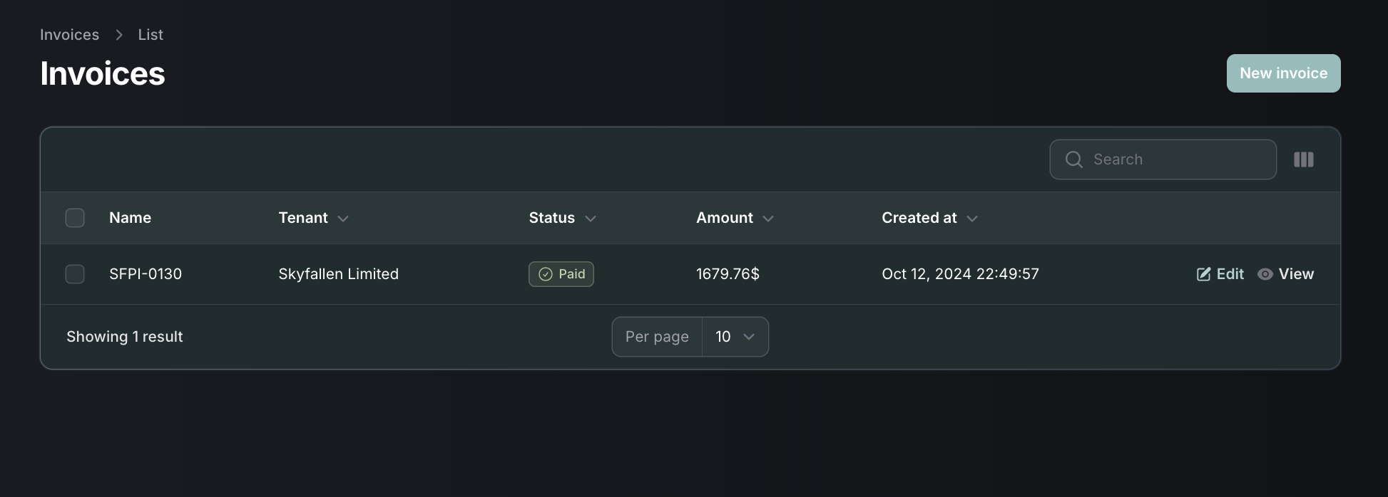

1. Invoice preview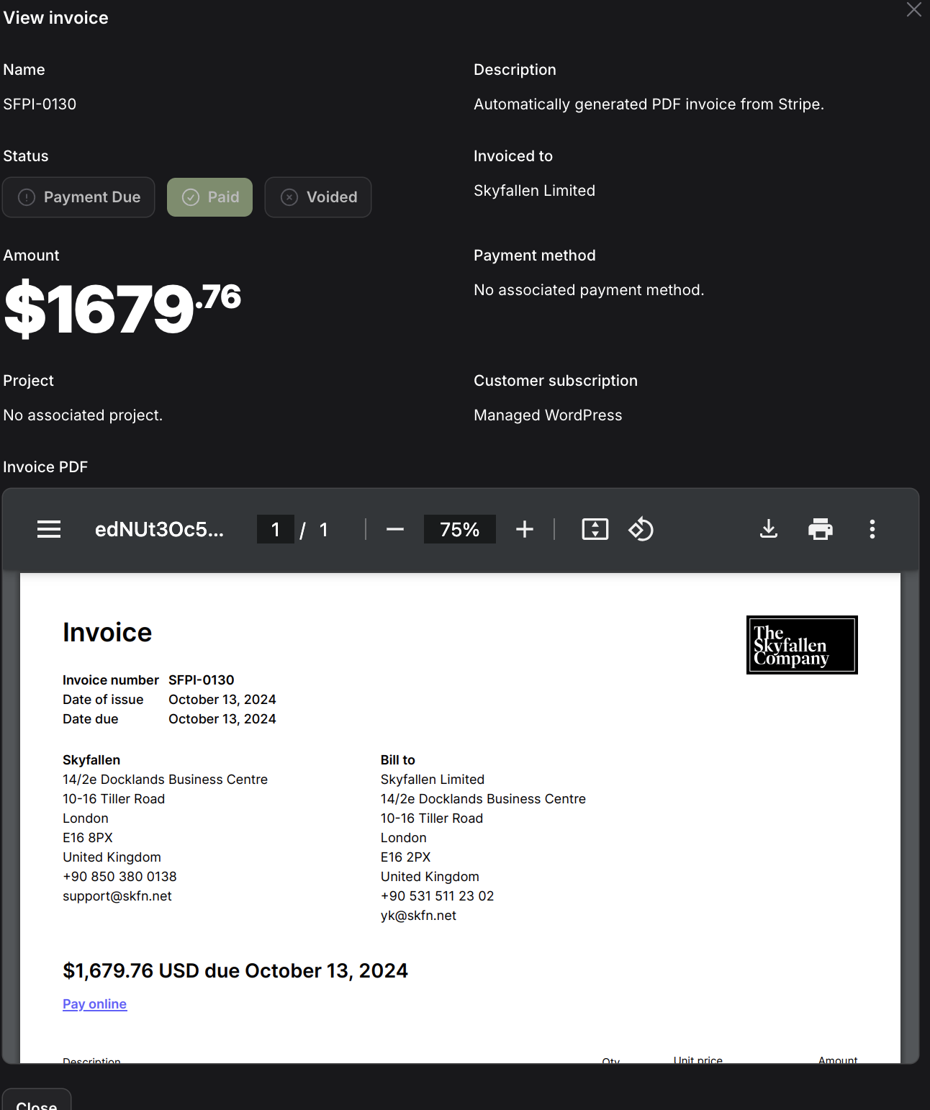
2. Document submission form

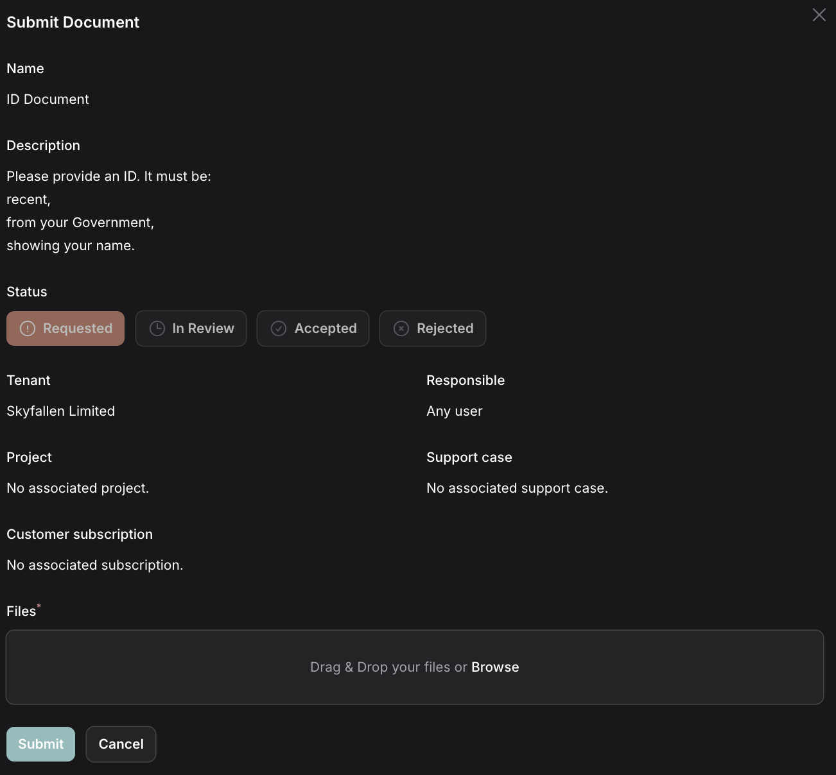

1. Support case creation form

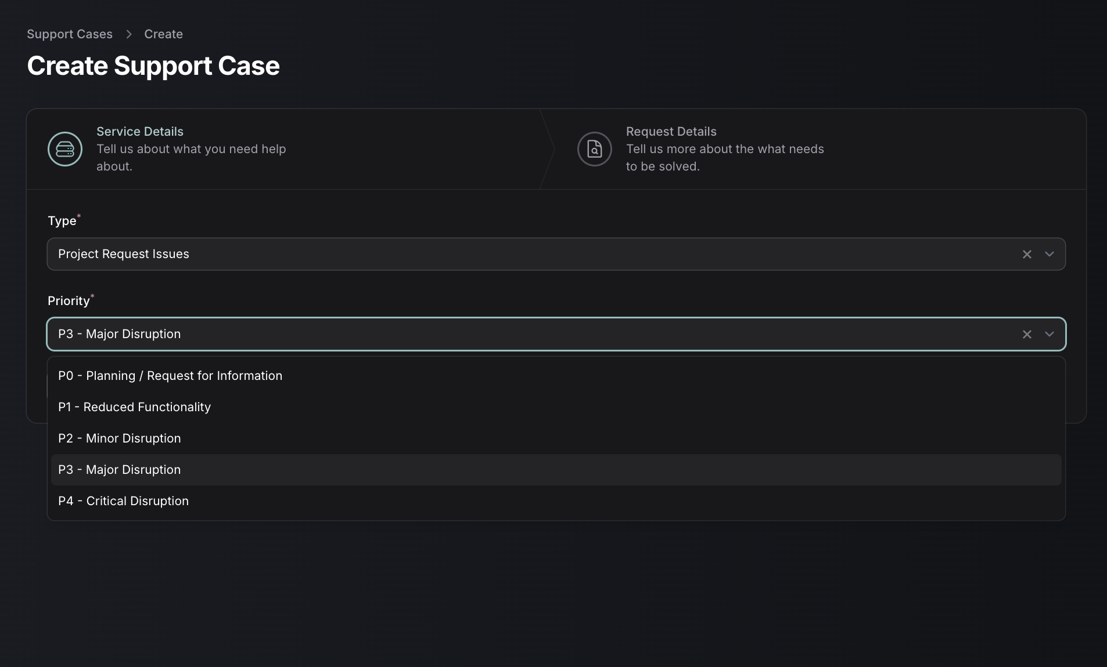

1. Support case overview

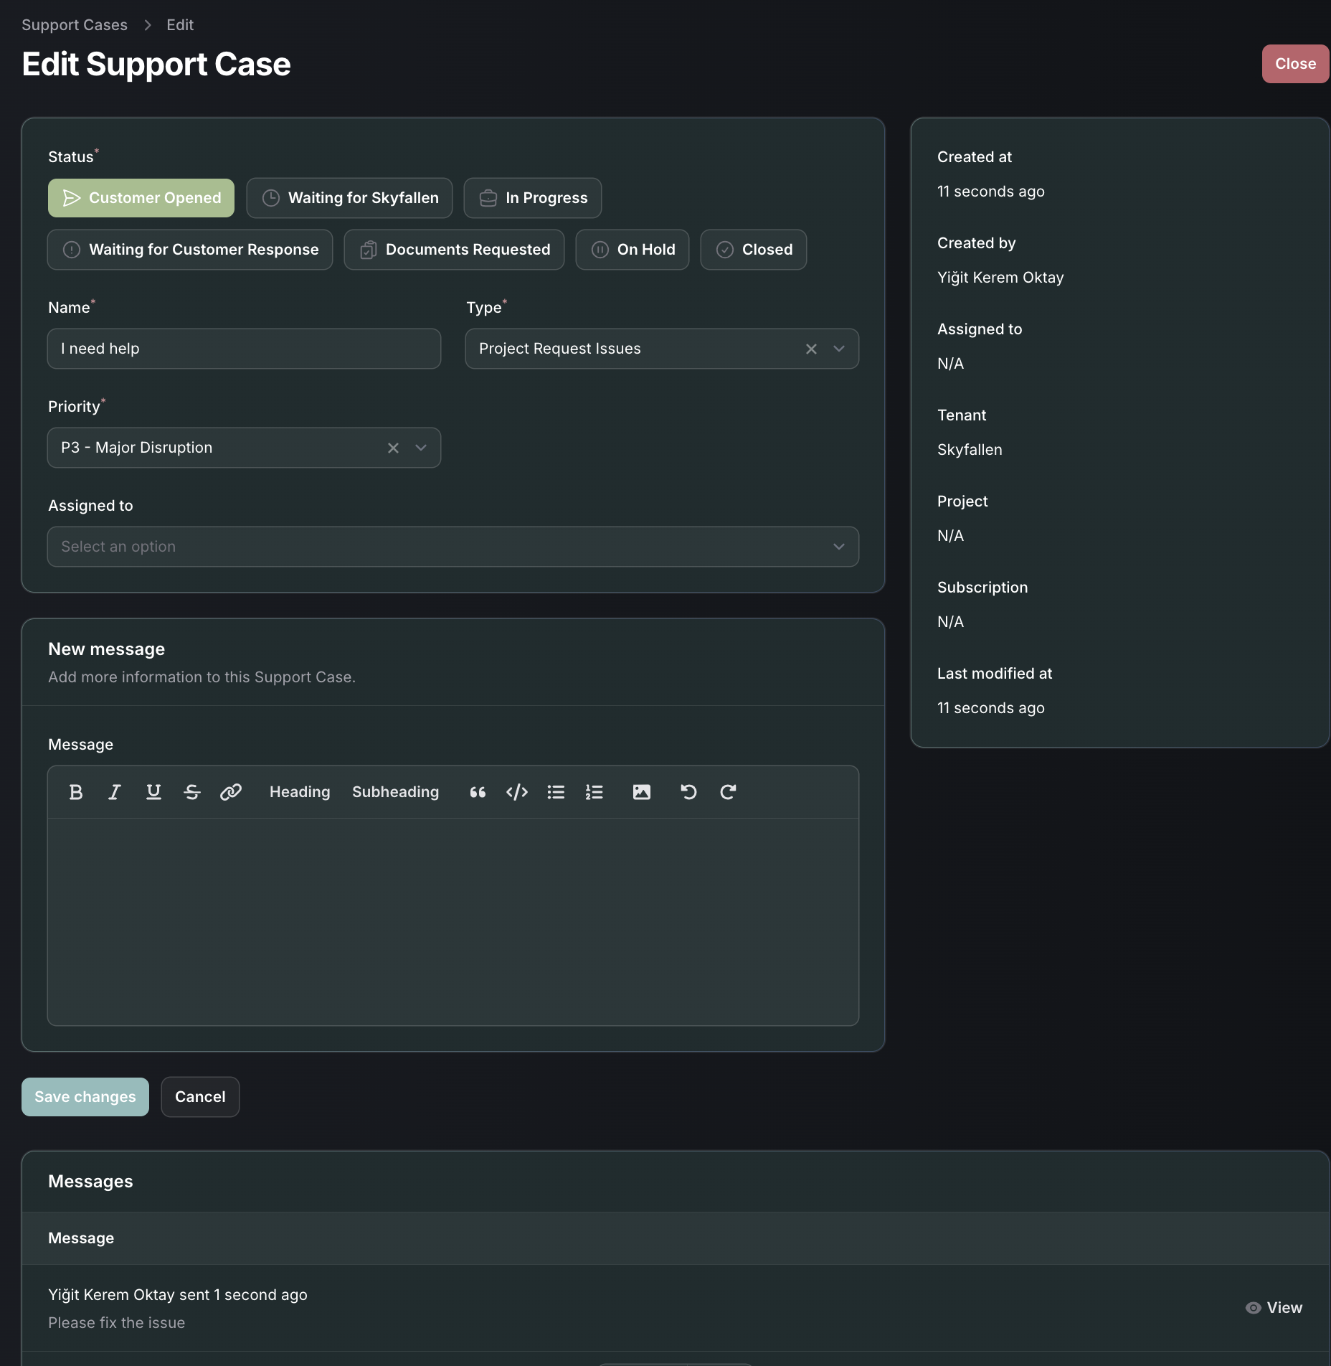

1. Payment method list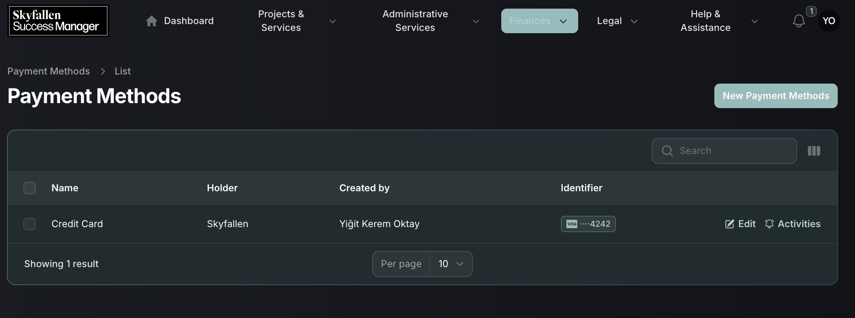
2. Payment method creation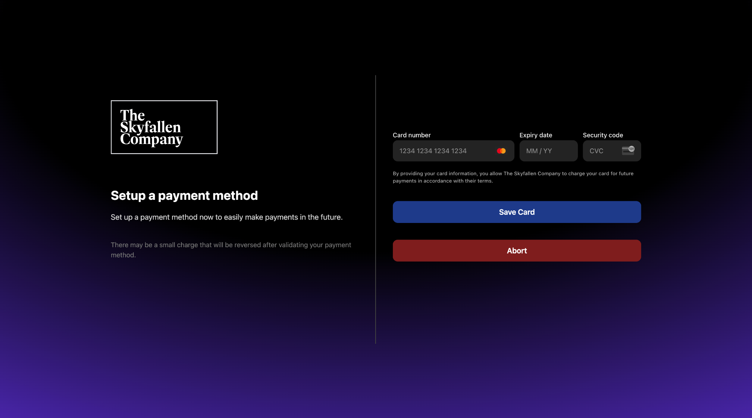
3. Agreements list

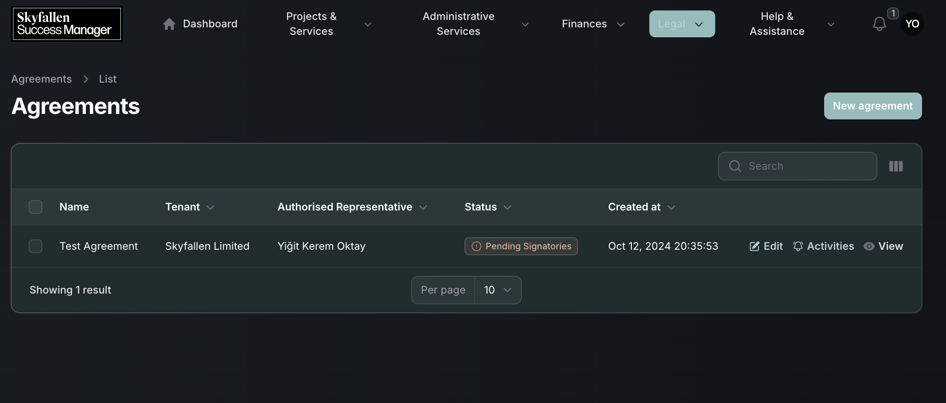

1. Agreement Preview

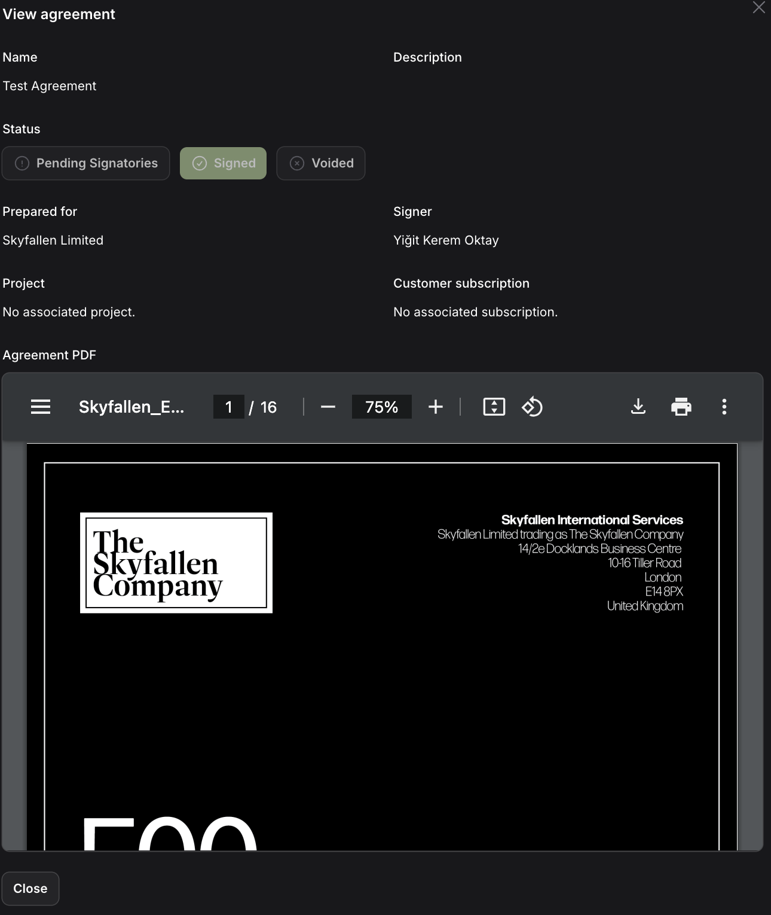

# Flowcharts

1. Auth Flowchart

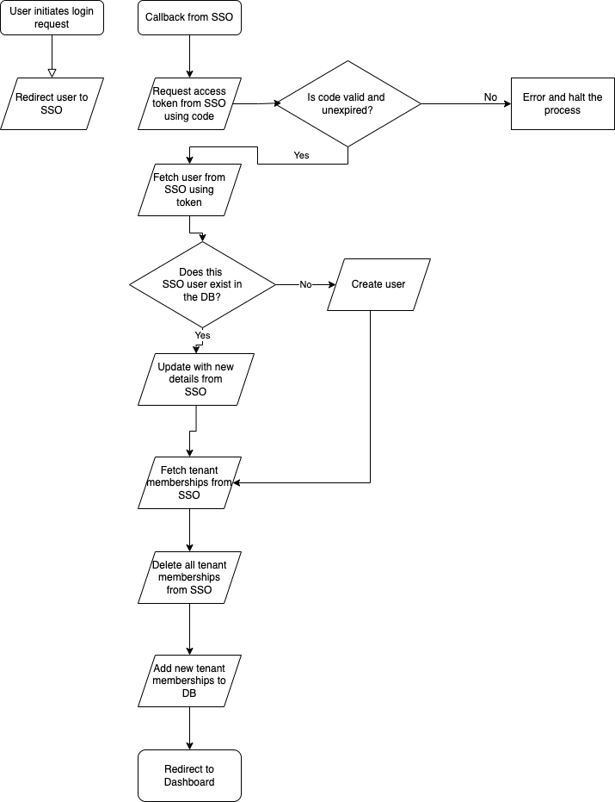

1. Project Flowchart

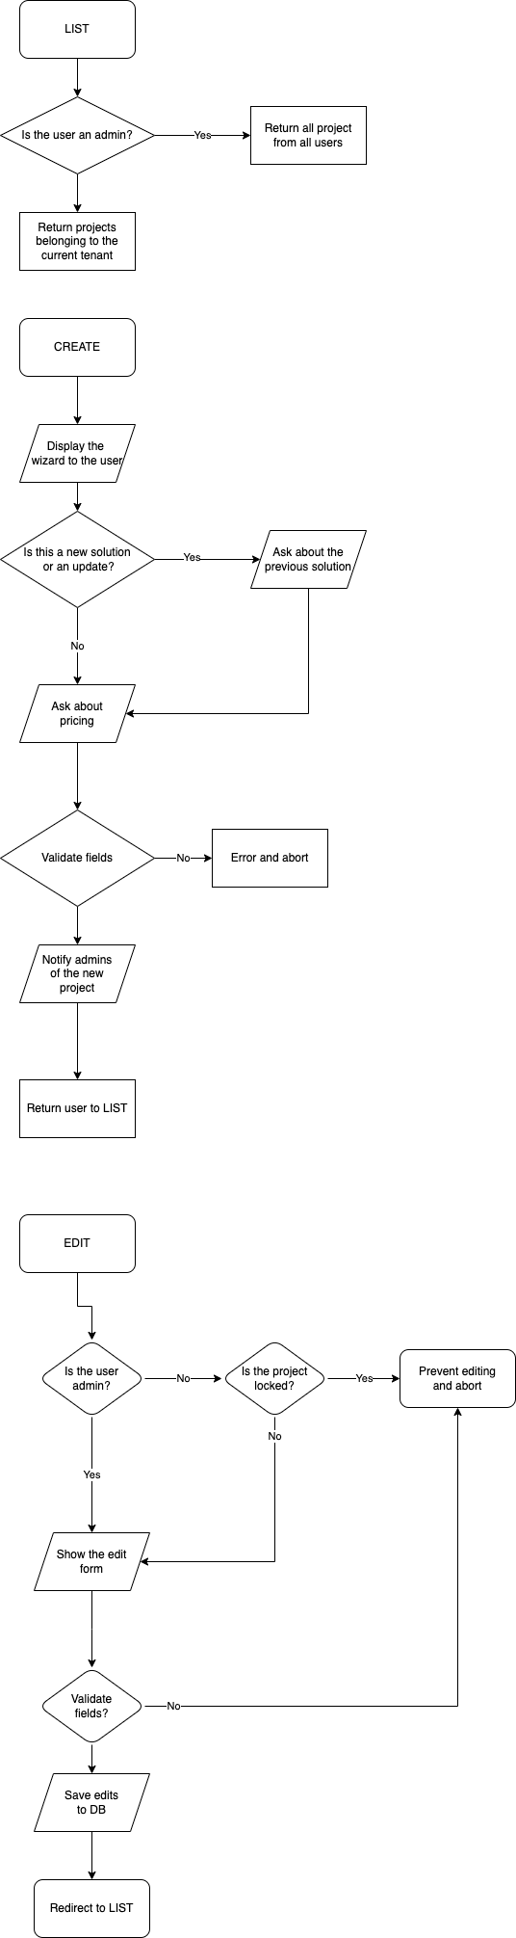

1. Subscriptions Flowchart

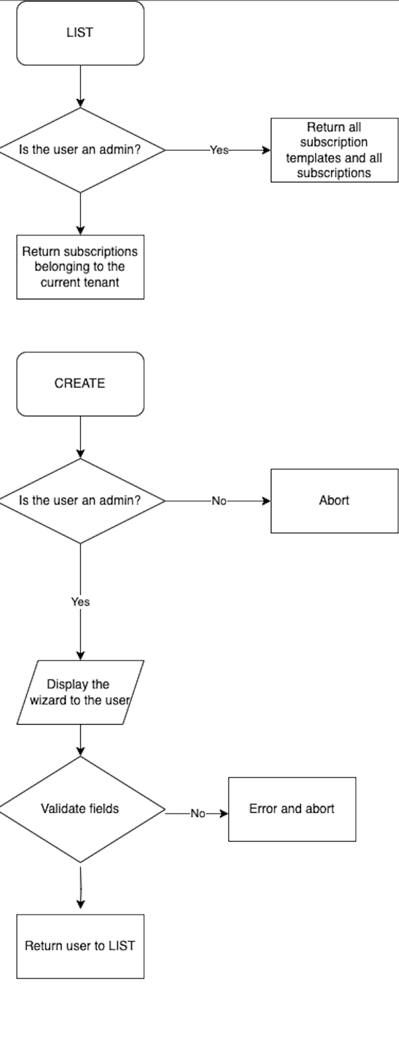

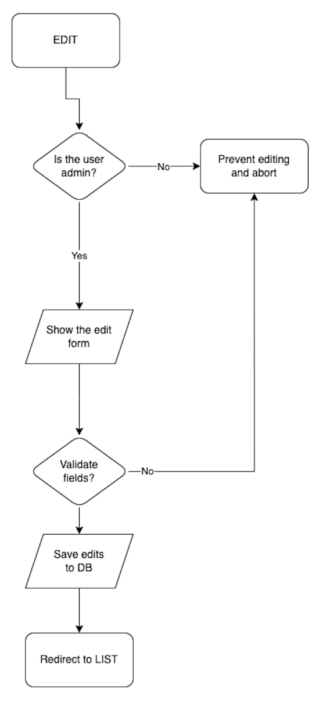

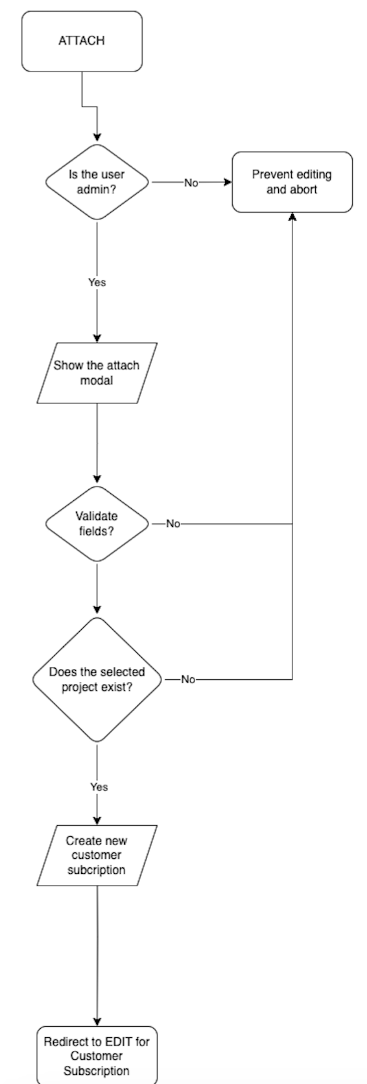

1. Agreements Flowchart

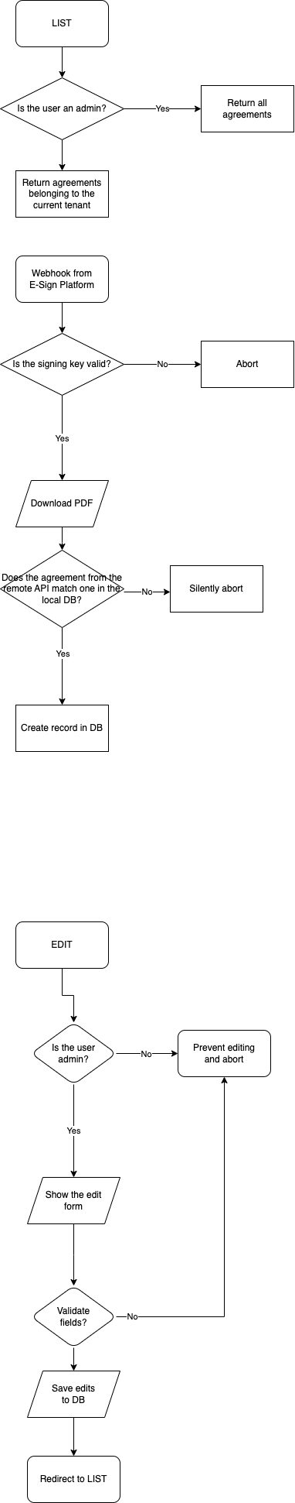

1. Documents Flowchart

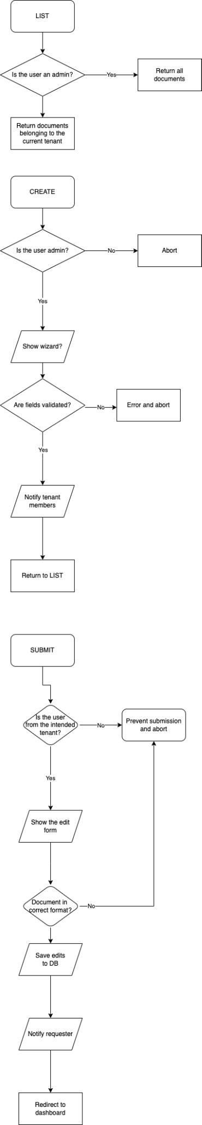

1. Invoices Flowchart

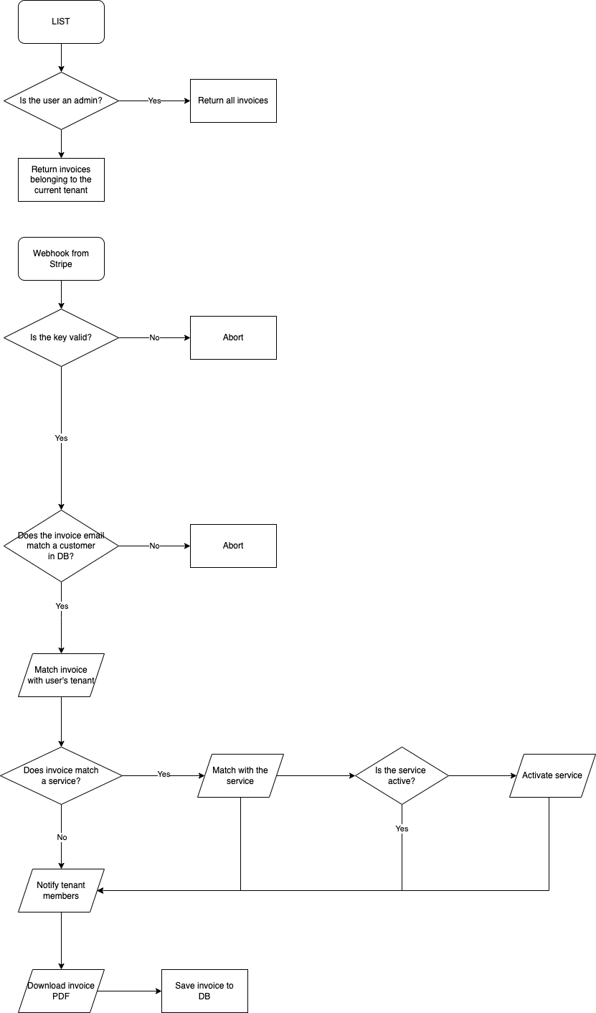

1. Payments Flowchart

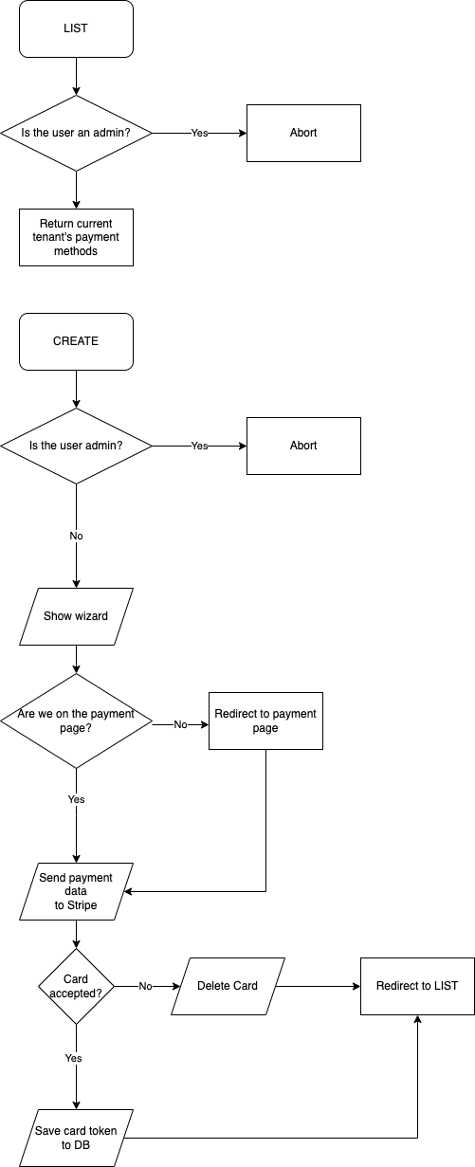

1. Support Cases Flowchart

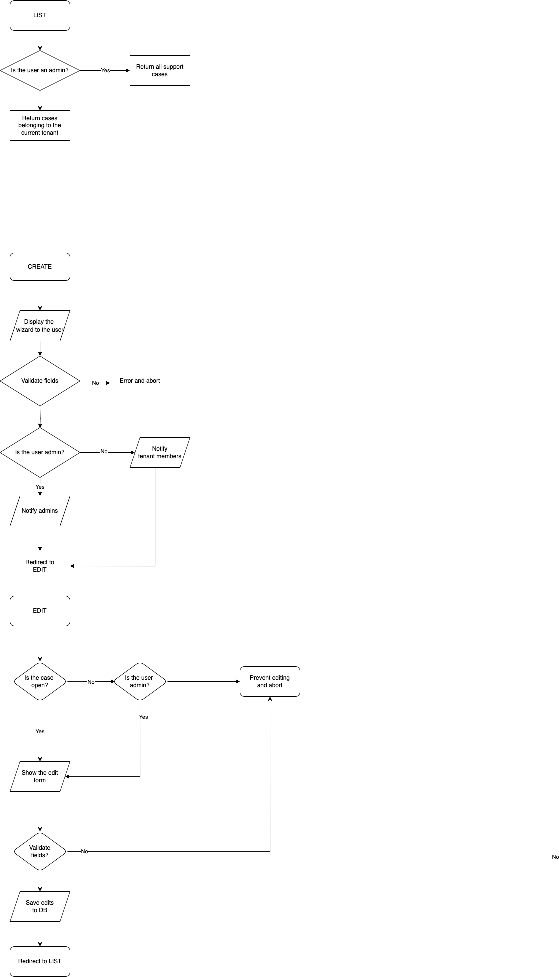

# 

# Test Plan

| Test Case | Methodology | Data | Expected Output |
| --- | --- | --- | --- |
| Authentication works | Visiting the web application URL and signing in through SSO. | Correct auth credentials. | User reaches the dashboard. |
| Creating a project request | Fill out the details of a project in the new project wizard. | All data filled out and the project type selected as “New Project” or “System Maintenance” or “Upgrade” | Project request created, admins emailed |
| All data but existing solution filled out and the project type selected as “New Project” |
| All data but existing solution filled out and the project type selected as “System Maintenance” or “Upgrade” | Project creation request fails |
| All required fields are not filled out |
| Editing a project request | Open the details of a project, change the requested details and hit save. | All required fields filled out and of the correct type. Project is not locked (either submitted or rejected) or the user is an admin. | Project is updated and notifications are sent. |
| Not all required fields filled out or not all are of the correct type. | Update fails and no notification is sent. |
| All required fields filled out and of the correct type. Project is not locked (either submitted or rejected) and the user is not an admin. |
|
| Paying for a project | Open a project that is pending payment, choose a payment method and sign. Finally, hit pay. | Missing signature or payment method. | No invoice generated. Payment fails and no change is made to the project. |
| Card does not have enough balance or the card transaction fails.   Stripe test card:  4000000000009995  CVC: 100  Exp: Any future date | Invoice generated but is unpaid. No change to the project status. |
| Card charged successfully.  Stripe test card:  4242424242424242  CVC: 100  Exp: Any future date | Payment successful. Project status transitions to the next stage. |
| Paying for a subscription | Open a subscription that is pending payment, choose a payment method and sign. Finally, hit pay. | Missing signature or payment method. | No invoice generated. Payment fails and no change is made to the subscription. |
| Attempt to pay monthly subscription using a payment method that is a bank account. |
| Card does not have enough balance or the card transaction fails.   Stripe test card:  4000000000009995  CVC: 100  Exp: Any future date | Invoice generated but is unpaid. No change to the subscription status. |
| Card charged successfully.  Stripe test card:  4242424242424242  CVC: 100  Exp: Any future date | Payment successful. Subscription status transitions to the next stage. |
| Signing an agreement | Open a pending agreement that is related to a subscription. | Document not signed. | Subscription is pending agreements. |
| Document signed by one of the signatories but there are multiple. |
| All signatories of the document have signed the agreement. | Subscription transitions to payment pending. |
| Creating a support case | Go to the support cases resource, hit create, fill out the details and once again, hit create. | Type is within the category Success Manager and all details are filled. | Notification sent to admins and case created. |
| Type is either within the Project category or Subscription category and a Project or Subscription can be and is selected respectively. |
| Message is too short or no subject. | Case is not created and error is returned. |
| Case is about a Project or Subscription but there are no projects/subscriptions or none are selected. |
| Requesting a document | Go to the Documents section, click New, fill the form and hit create. | User is not an admin. | Request is blocked. |
| Required fields are not filled out. |
| Selected user is not in the selected tenant. |
| All fields filled out and are of the correct type. | Document requested and email sent to customer. |

# 

# Record of Tasks

| Task No: | Planned Action | Planned outcome | Time estimated | Target completion date | Criterion |
| --- | --- | --- | --- | --- | --- |
| 1 | Initial Meeting with the Advisor | A detailed chat transcript is noted down. Requirements of the client understood. | 1hr | 04/24 | A |
| 2 | Success criterion are planned. | A list with all SC is created. | 2hr | 04/24 | A |
| 3 | Relevant frameworks and programming languages are researched. | Programming languages and frameworks suitable for the multiple platforms of the application are chosen. | 3hr | 04/24 | A |
| 4 | Second meeting with the advisor. | Proposed solution is discussed and the SC are finalized. | 1hr | 05/24 | A |
| 5 | Class Diagram | Database structure and possible object fields are planned | 4hr | 06/24 | B |
| 6 | Interface Design | A UI/UX design to bring to the table to the client is created | 6hr | 06/24 | B |
| 7 | Testing Plans | A test plan to validate functionality of the program is created. | 3hr | 06/24 | B |
| 8 | First Prototype | Initial functionality is programmed.No API integration is made but rather manual inputs are used. | 10hrs | 06/24 | C |
| 9 | Second Prototype | A test integration with Stripe is made for testing financial transactions. | 10hrs | 06/24 | C |
| 10 | Meeting with the Client | Confirm the progress in the right direction, add additional test scenarios if needed and update SC. | 2hrs | 06/24 | C |
| 11 | Third Prototype | API integration is completed. Stripe webhooks integrated into the application. | 6hrs | 07/24 | C |
| 12 | Fourth Prototype | User interface is completed and all functionality is made available from the interface.  Authentication is completed. | 10hrs | 07/24 | C |
| 13 | Final Prototype | All permissions are confirmed and added into the project. User role checking, input validation and permission checks are put into place. | 10hrs | 07/24 | C |
| 14 | Release Candidate | An RC version is deployed and made available for the advisor to test. | 4hrs | 07/24 | C |
| 15 | Final Evaluation | A final meeting with the advisor is made to confirm functionality. | 2hrs | 07/24 | C |